6/2/2025

Power Automate:

Schedule Email with OneDrive File Attachment

Prepared By: Xitiz Basnet

**Power Automate: Schedule Email with OneDrive File Attachment**

**Objective**

This guide outlines the steps to create an automated scheduled email using Power Automate that sends a specific OneDrive file to a designated recipient every hour.

## ****Pre-requisites****

* Access to Microsoft Power Automate: <https://make.powerautomate.com>
* OneDrive for Business with the target file stored
* Access to Office 365 Outlook
* Recipient email address

## ****Step-by-Step Instructions****

### **1. Log In to Power Automate**

Go to <https://make.powerautomate.com> and sign in with your organizational account.

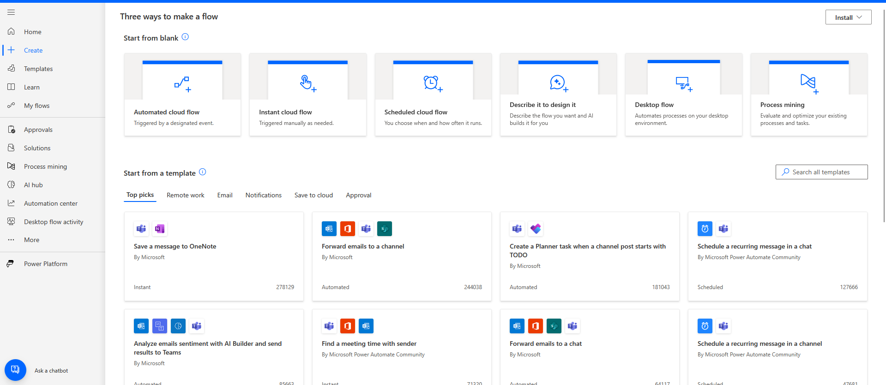

### **2. Create a Scheduled Flow**

* In the left-hand navigation menu, click **+ Create**.

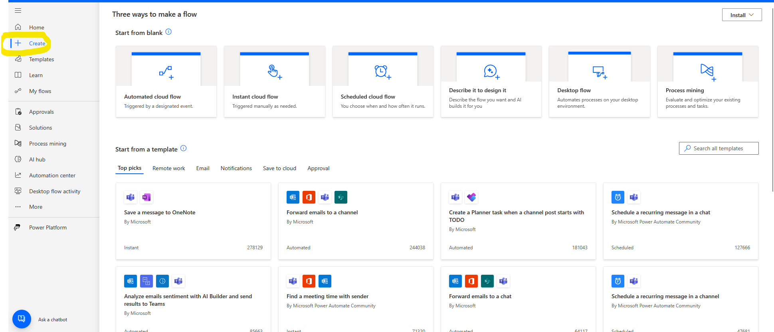

* Select **Scheduled cloud flow**.

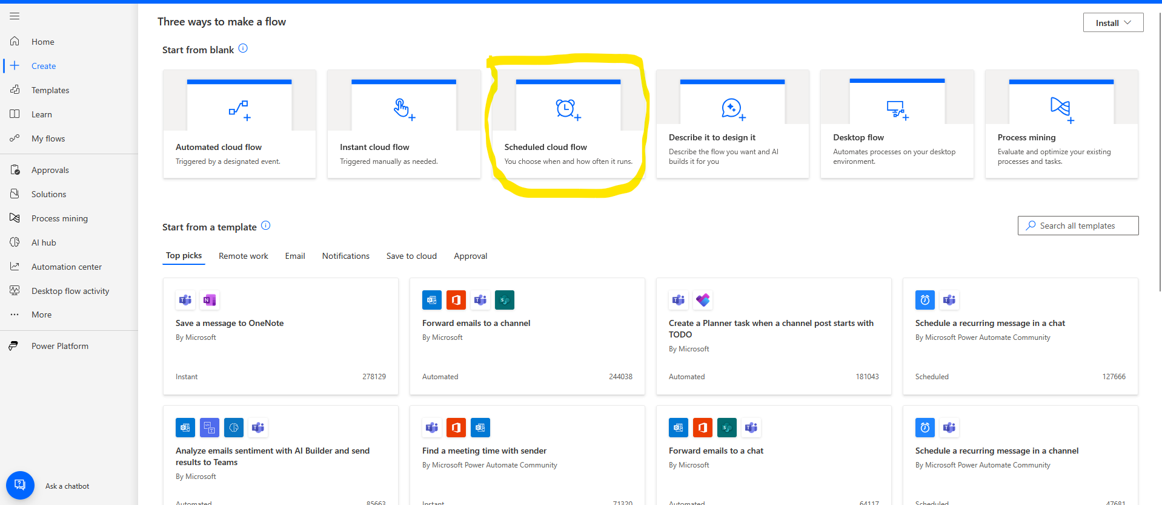

* Enter a **Flow name**, e.g., Hourly Daily Work Update.

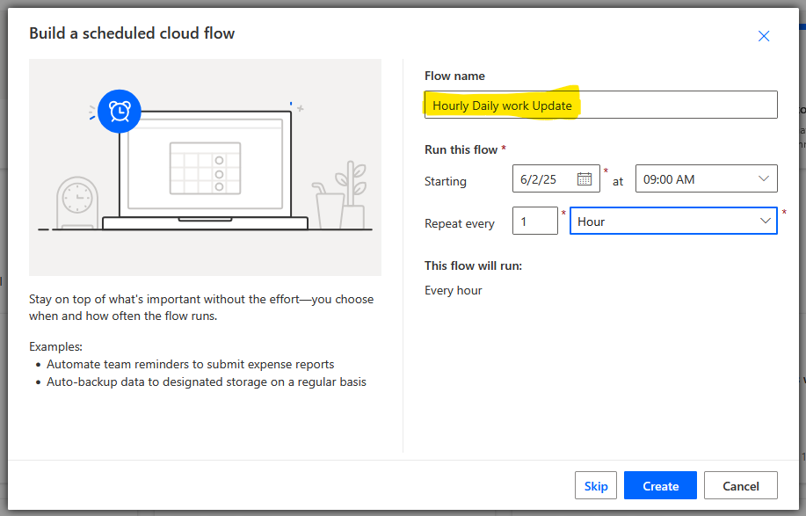

Configure the **start time**:

* **Date**: 6/2/2025 & **Time**: 9:00 AM

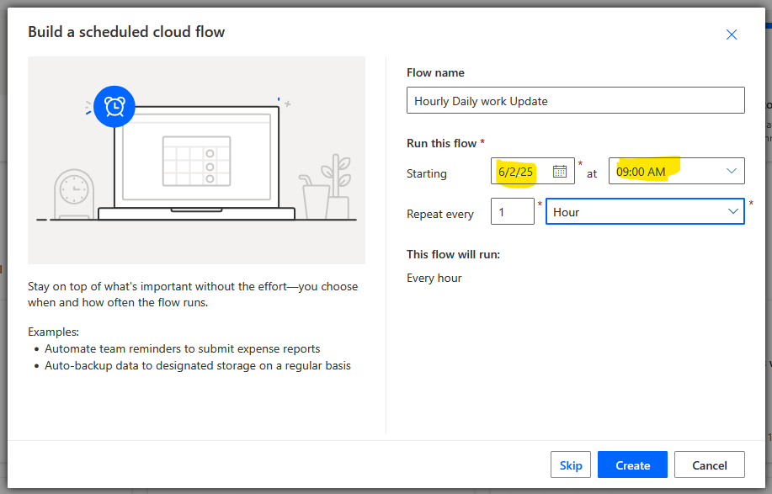

* Set the recurrence to **Every 1 hour**.

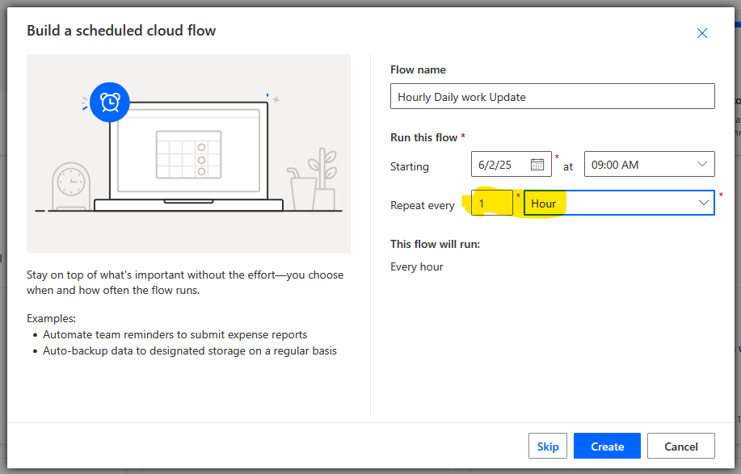

* Click **Create**.

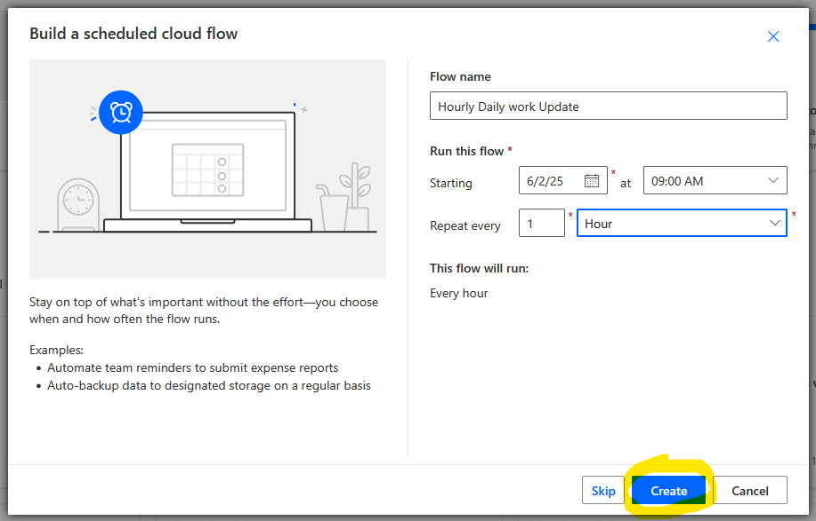

### **3. Configure the Recurrence Trigger**

Once the flow is created, a **Recurrence** trigger will appear automatically.

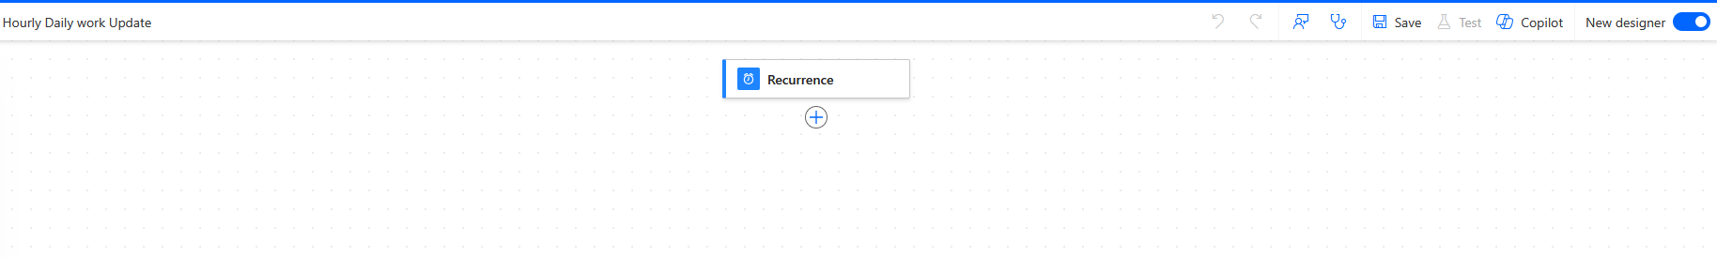

### **4. Get File Content from OneDrive**

* Click the **+ New step** icon below the recurrence block.

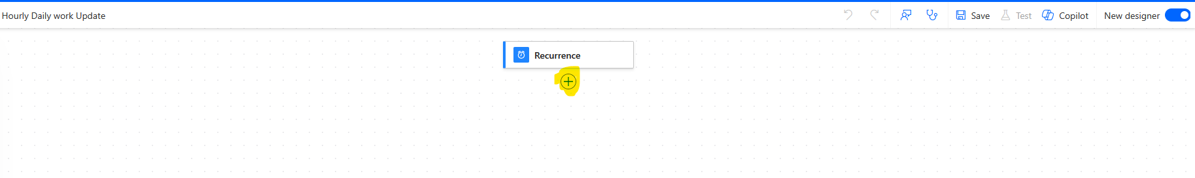

* In the search bar, type: Get file content.

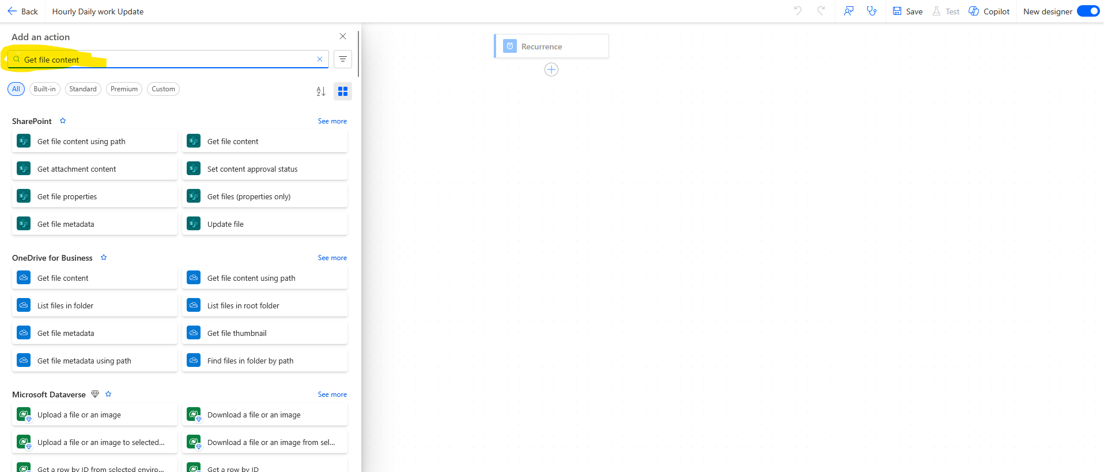

* Choose the **OneDrive for Business** option.

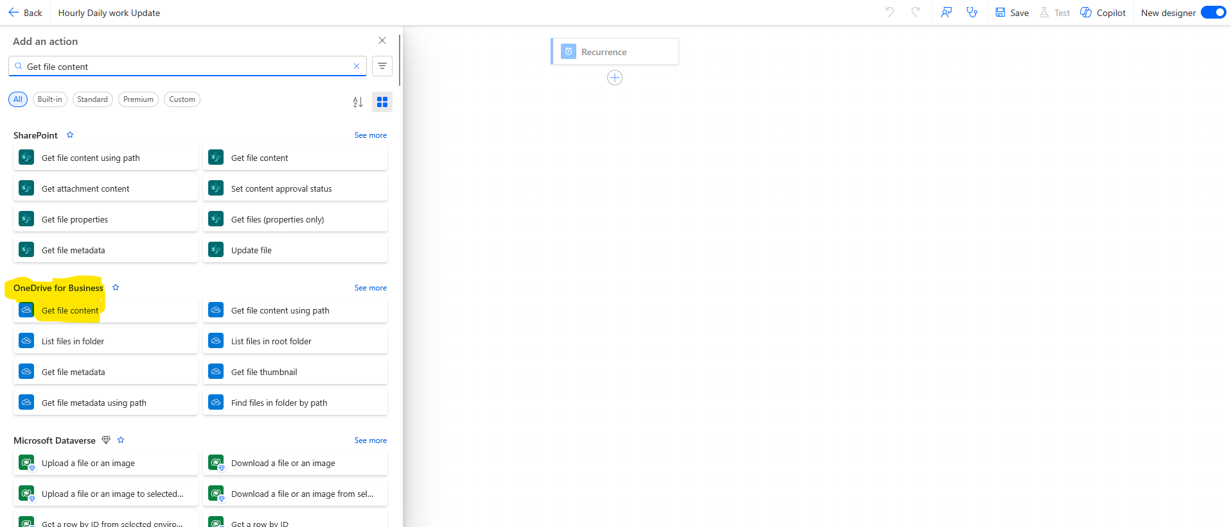

Under the **File** field:

* Click the folder icon to browse and select the file you want to send.
* Example file path: /Send Daily Excel Report/Send Daily Excel Report.xlsx

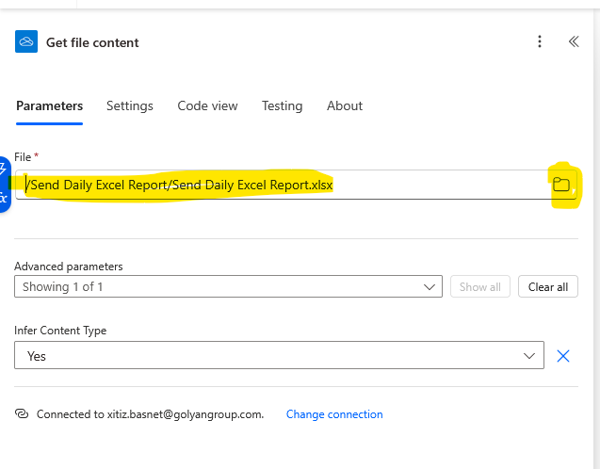

* Leave the **Options** field blank under Advanced Parameters.

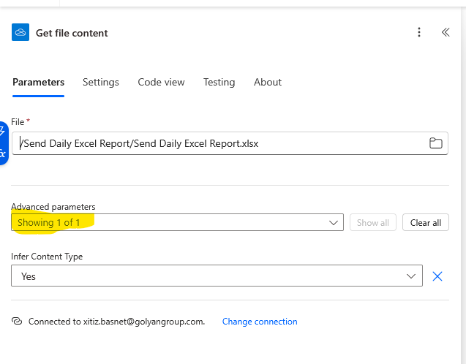

* Set **Infer Content Type** to Yes.

### 

### **5. Send Email with Attachment**

* Click **+ New step**.

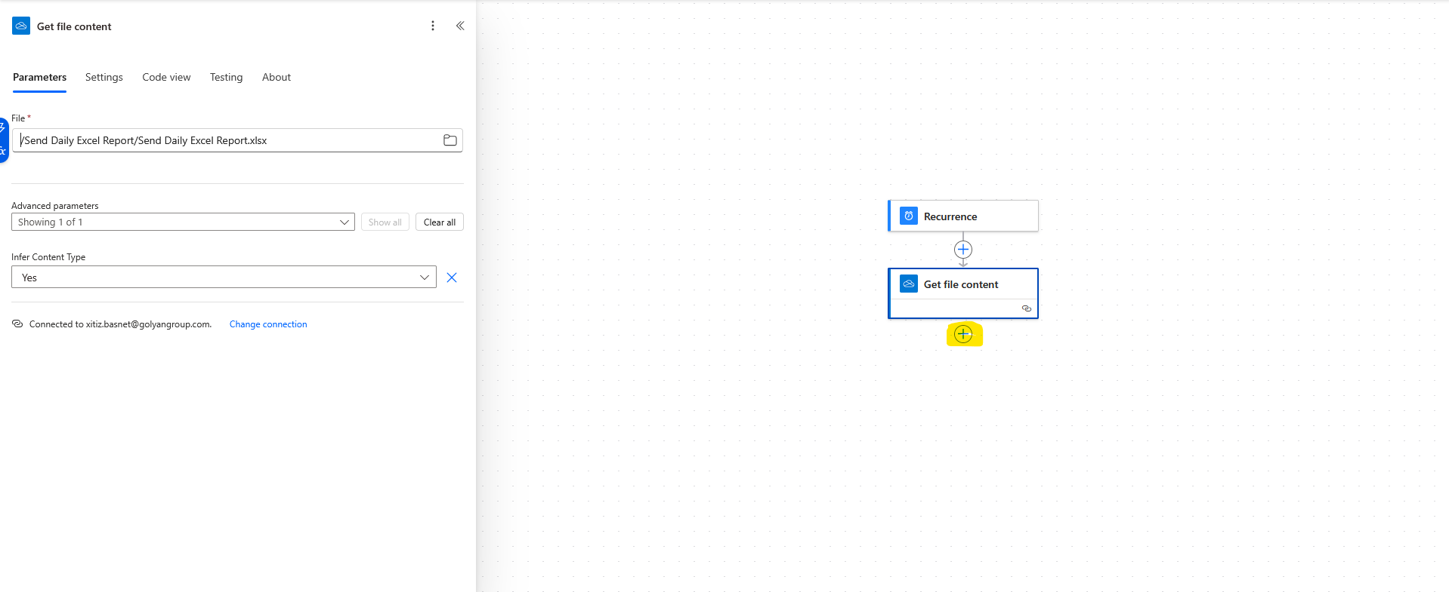

* Search for Send an email (V2) and select the option under **Office 365 Outlook**.

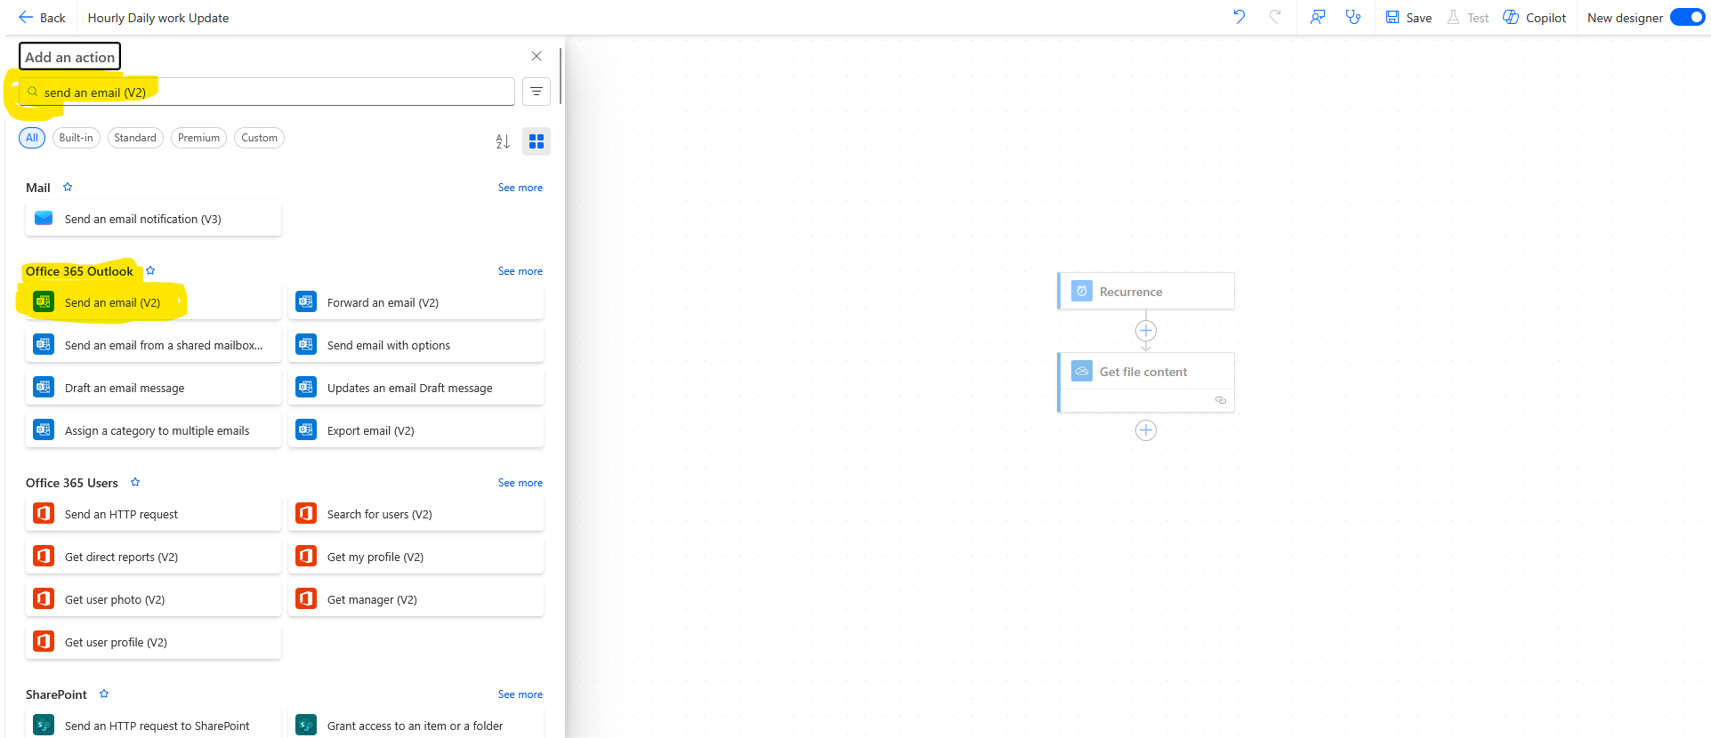

Configure the email as follows:

* **To**: Enter the recipient’s email address.

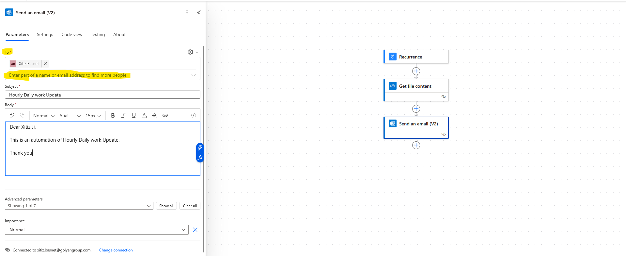

* **Subject**: Hourly Daily Work Update

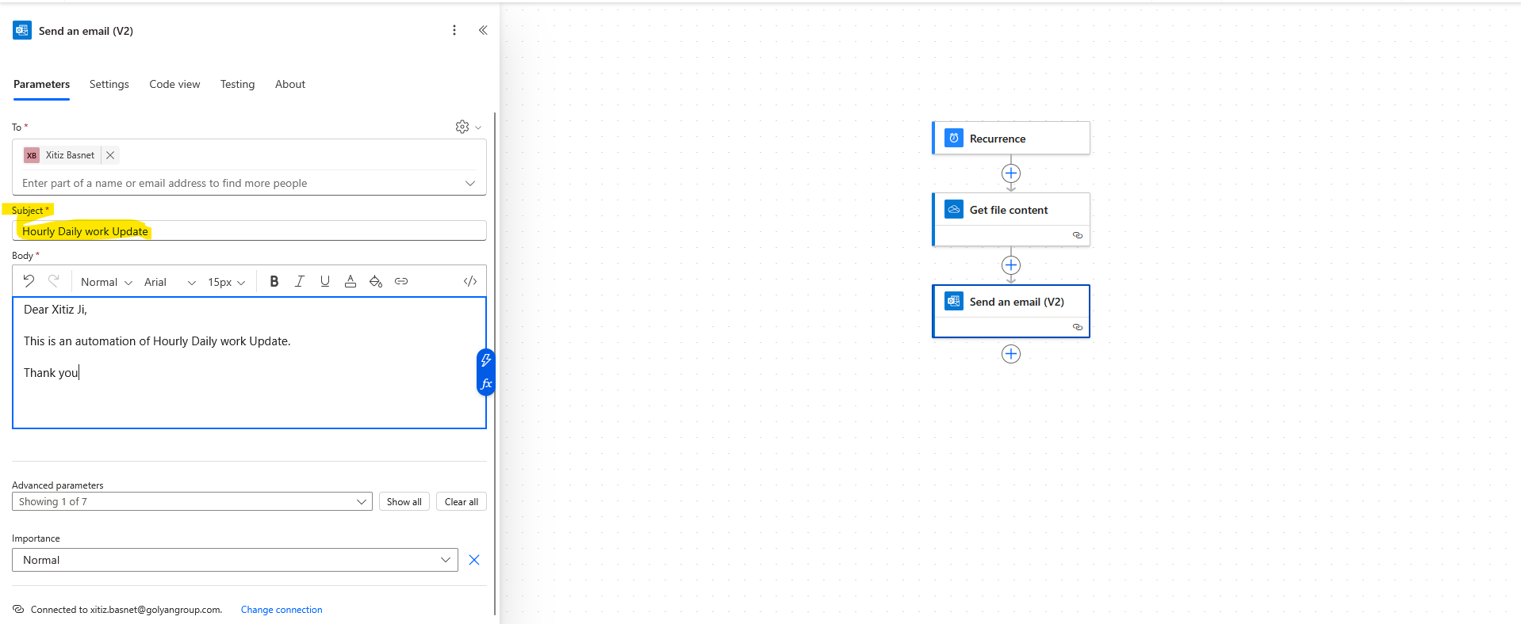

* **Body**: Write the desired message content.

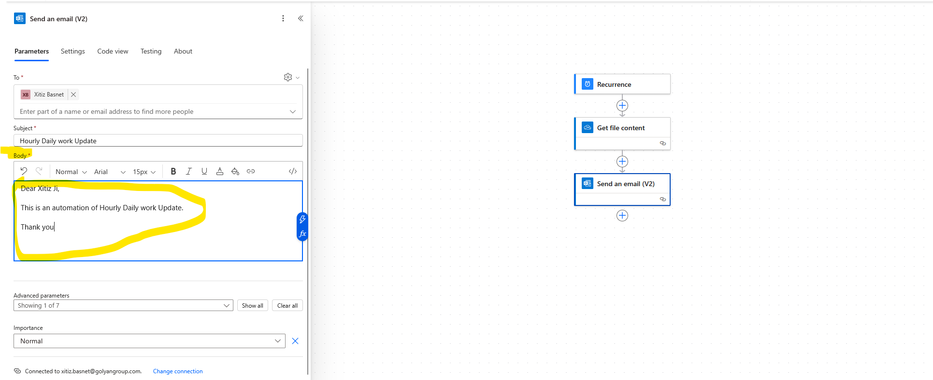

* Expand **Advanced options**:

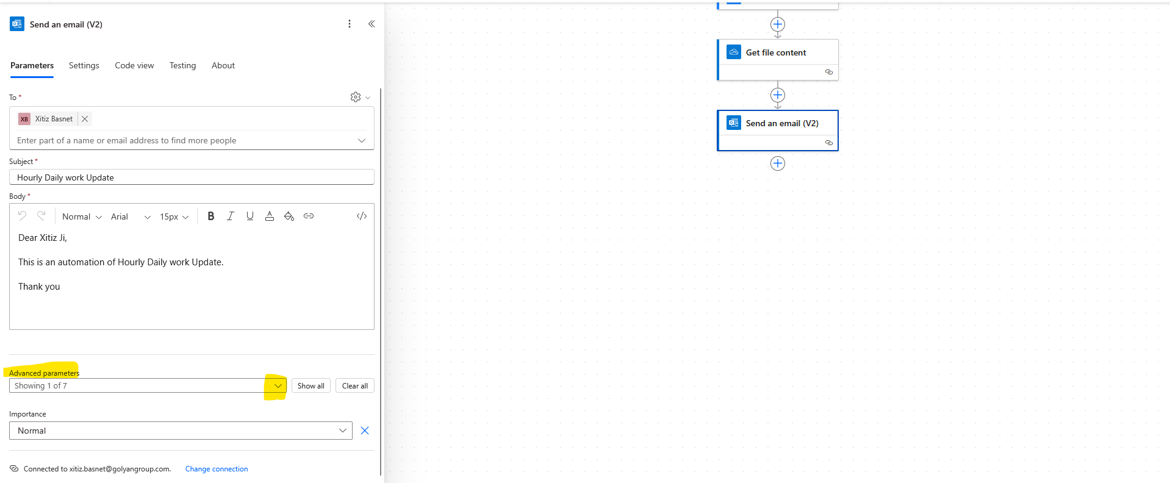

* Now select the attachment file

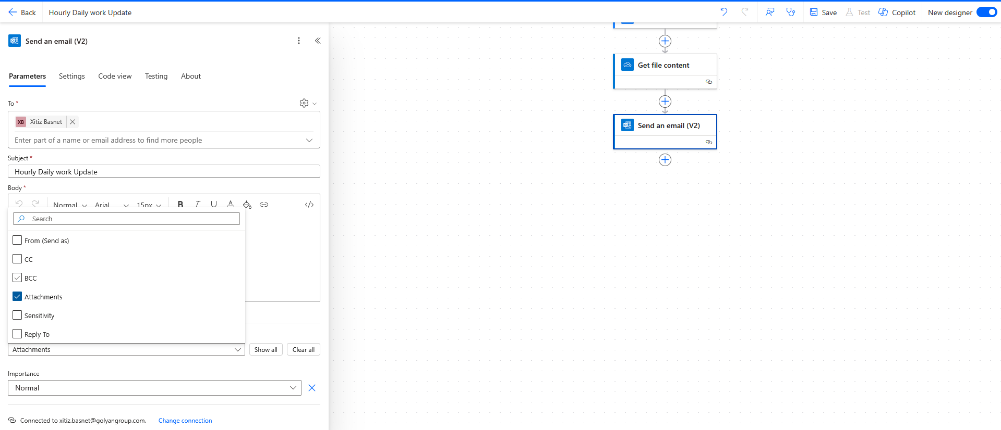

• Add an **Attachment Name**: Hourly Daily Work Update Excel File.xlsx

• Set **Attachment Content** to the file content from the previous step.

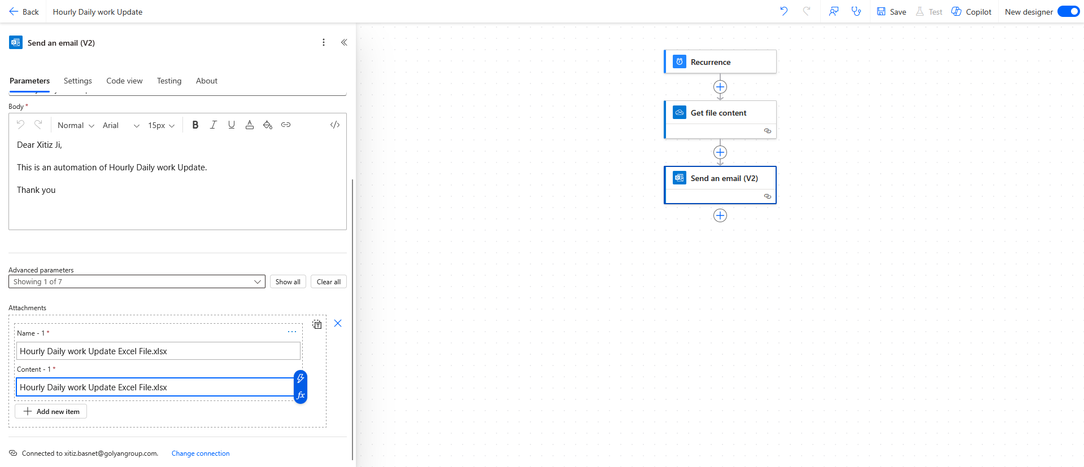

### **6. Save and Test the Flow**

* Click **Save** to store your flow.

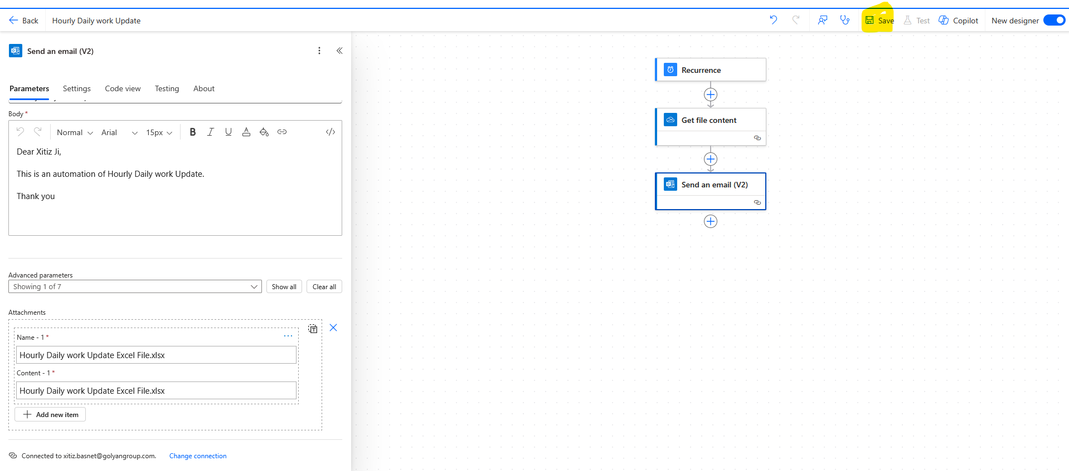

* Click **Test** in the top right corner.

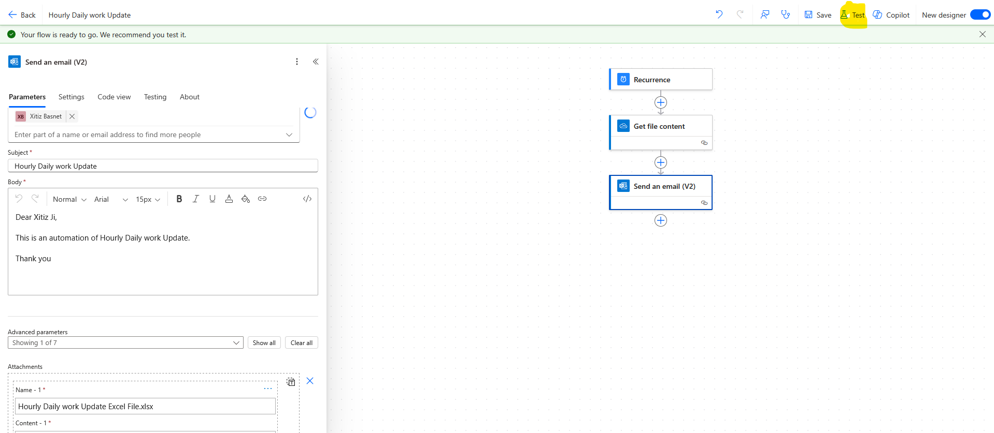

* Select **Manually** and click **Test**.

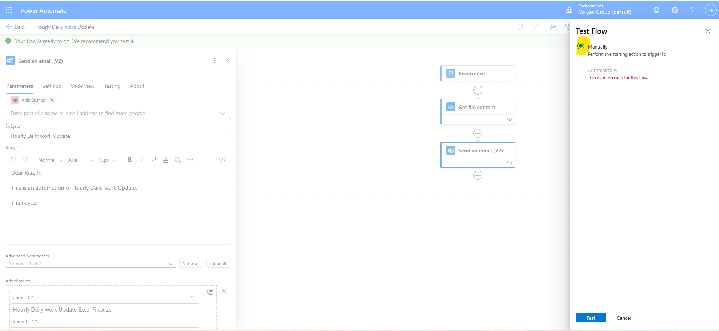

* Click **Test**.

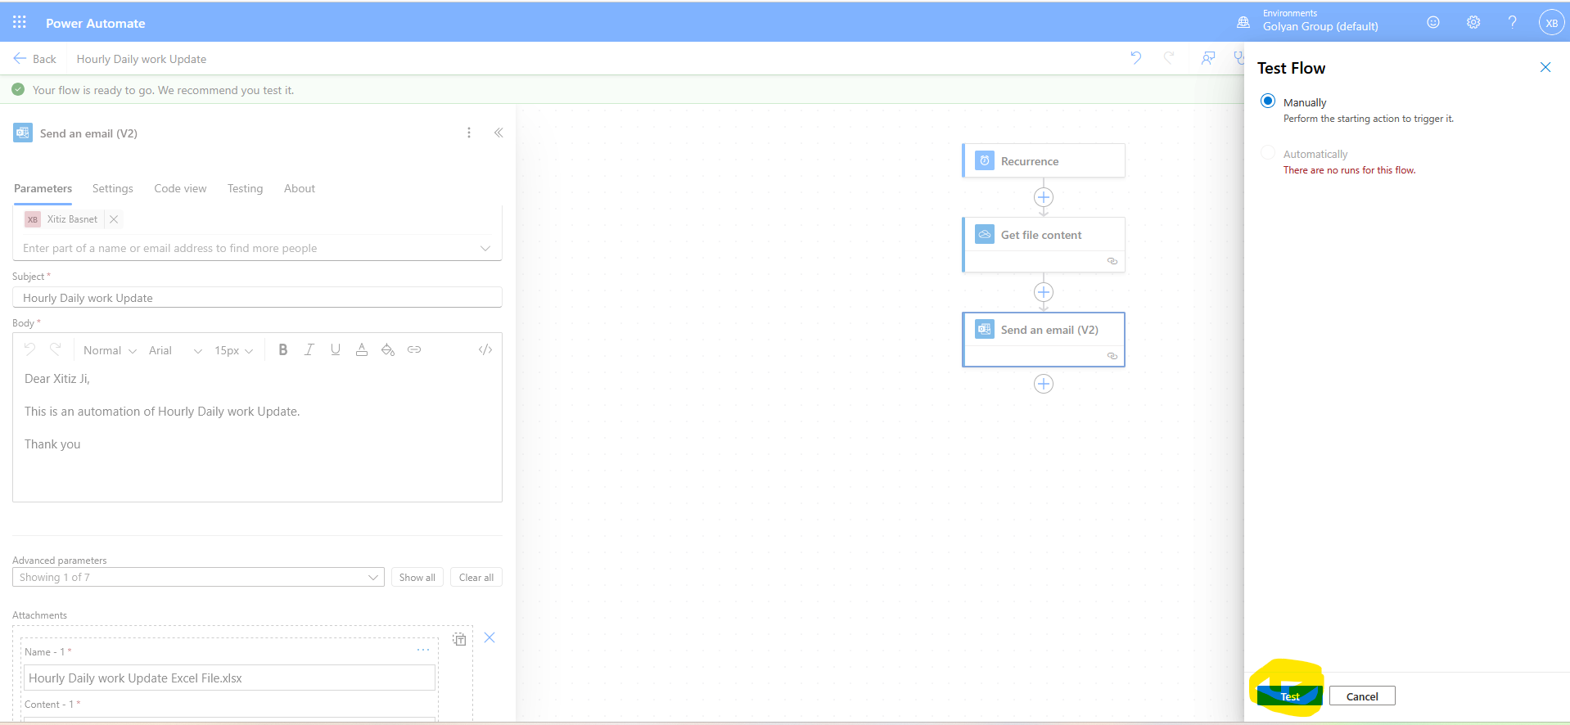

* Click **Run Flow**.

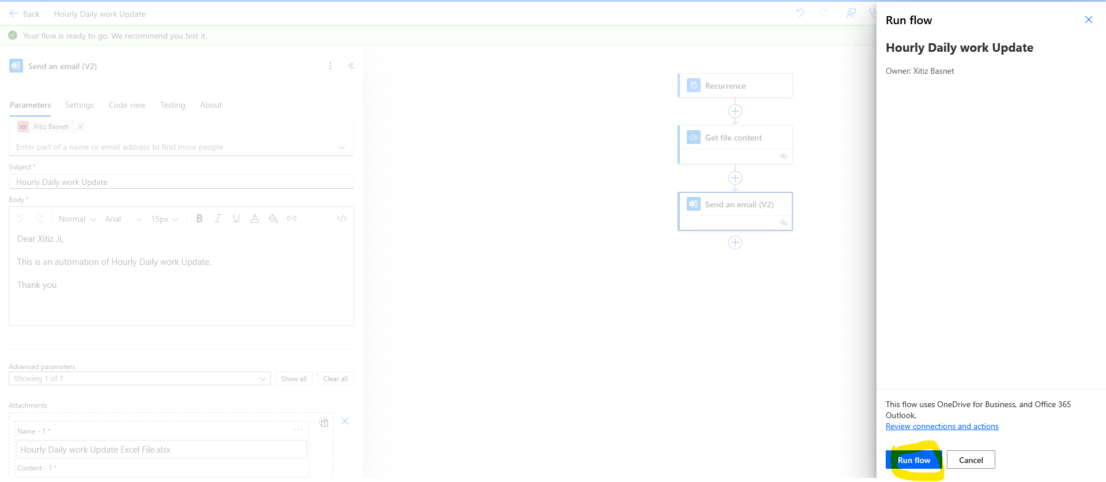

* After a few moments, a **Success** message should appear.

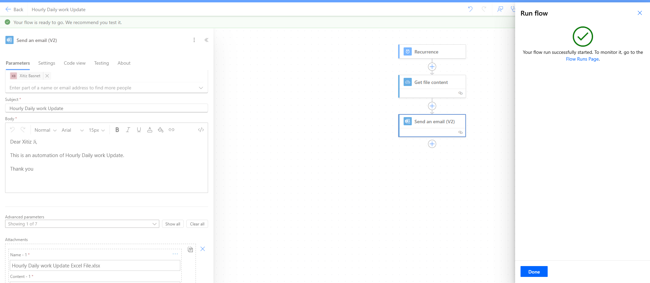

* Check the recipient mailbox to confirm delivery.

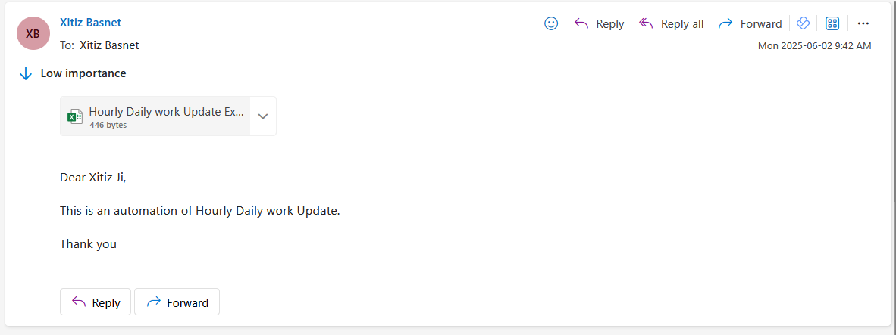

* Click **Done**

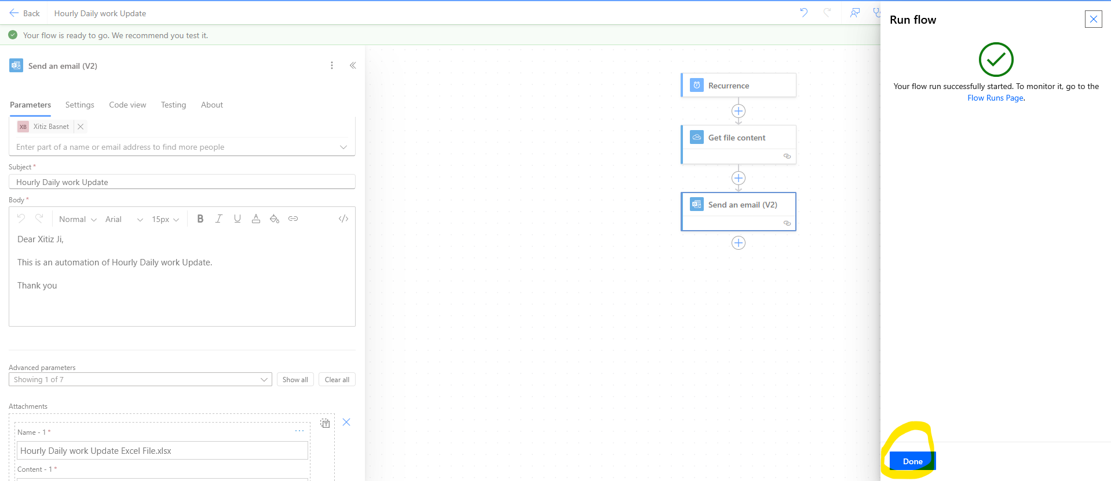

### **7. Completion and Verification**

* After successful testing, return to the dashboard.

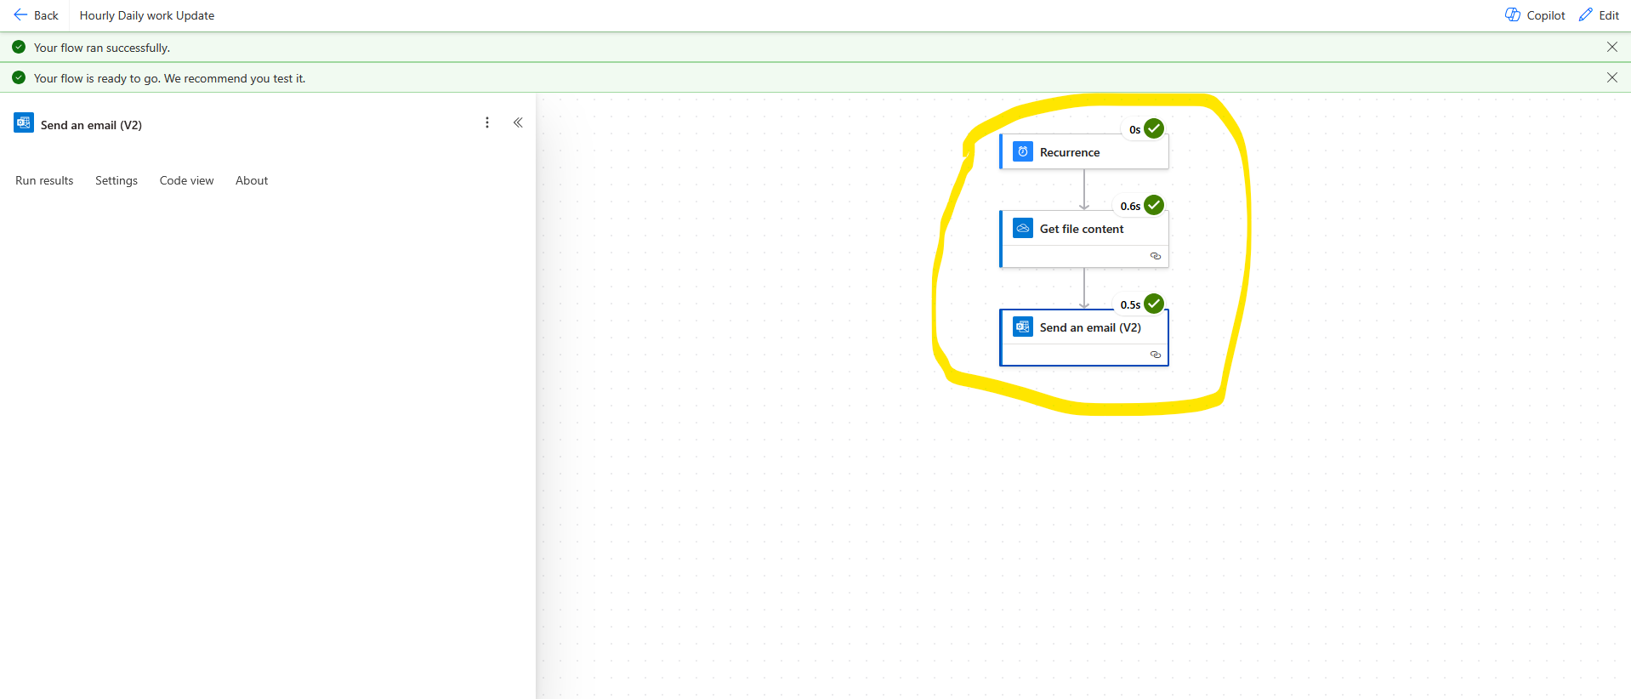

* You should see a green **checkmark** next to your flow, indicating it’s active and functional.

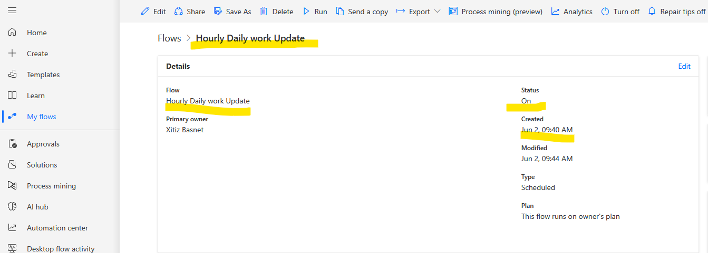

## ****Conclusion****

You have now successfully created and tested a scheduled Power Automate flow that sends a OneDrive file via email every hour. You can modify the flow to attach different files or send to multiple recipients as needed.

**Next Steps**

* Experiment with sending other types of files.
* Explore additional Power Automate connectors and triggers.
* Consider adding conditions, filters, or approval steps for more complex workflows.

**Thank you.**  
*Power Automate simplifies your routine tasks—explore and automate more!*